**Dillon Elementary Points of Pride**

**Our Community**

* Dillon Elementary School’s community spans a large section of the district. We are unique in that we are the only Kindergarten through Third Grade building in the district. We encompass students from the northern end through the most southern end of our district.
* Dillon has 330 students in grades Kindergarten through Third Grade. Our ethnic demographics are approximately 59% white, 21% African American, and 20% other.
* Dillon Elementary has had wonderful support from the community over the past years. We have 4 area churches that provide us with a tremendous amount of support and donations.
  + **C:\Users\cdillard\AppData\Local\Microsoft\Windows\Temporary Internet Files\Content.IE5\VI421O1W\MC900391320[1].wmf** **Holy Redeemer Catholic Church** members volunteer to have our children read to them in our Media center at least 2 days a week. The members of the church also provide food baskets, holiday help, hats, scarves, mittens, and school supplies every year.
  + **Bristol Road Church of Christ** mentors some of our students once a week and supplies weekly food baskets and clothing to families through their Food Closet program.
  + **Flint Central Church of the Nazarene** has supplied students with winter gear such as hats and gloves.
  + **Bristolwood Community of Christ Church** supplies 15 of our families with food bags weekly through The Weekend Food Project.
* Dillon Elementary has great support through other members of our community. We receive a lot of services for our families and students on a daily basis.
  + **The Flint Senior Center** has donated school supplies, mittens and scarves to our students.
  + **Foster Grandparent Program** provides 2 grandparent volunteers that work in classrooms Monday-Thursday every week to give struggling students additional one-on-one help.
  + **McTeacher Nights at McDonalds** allows us to have a few nights a year at our local McDonald’s in which we receive 10-15% of the proceeds that go to our school. Our teachers design signs that we use to decorate the lobby. Teachers and support staff members participate the entirety of the event.
  + **The Burton Fire Department** donated many, many winter boots this school year for students who did not have a pair of boots.
  + **The Burton Police Department** participated with our school in the Shop with a Hero holiday program.
  + **The Old Newsboys of Flint** donated coats and shoes to our students who were in need of warm coats and a nice pair of shoes.
  + **Verizon** just recently donated school supplies to our school through a nomination from one of our parents. The school supplies were divided among our teachers and we even have some available to give to our students!
  + **Knights of Columbus** donated several new coats to our students.

We are truly grateful for these wonderful community organizations and the support they provide to our Dillon family!

**Opportunities for Parent and Family Involvement**

**Parent Club** meets the second Tuesday of each month to plan fundraising events and to problem solve concerns that parents may have. We have become a "community center" in an urban area that lacks a "city center" or gathering place. We have a ***great*** relationship with our Parent Club who continually strives to support our kids by providing: money for field trips, bringing in plays, authors and science programs, the Flint Institute of Music, McDonald’s Nights, Bucket filler prizes and the end of the year school wide party. Parent Club is also instrumental in providing all students with 2 FREE books a year even with the lack of federal funds, one for their birthday and one at the yearly RIF (Reading Is Fundamental) book distribution. Parent Club also provides a yearly volunteer luncheon for all of our volunteers who help us throughout the school year.

**Latchkey** is a program that provides safe, nurturing, and quality childcare for our students. There are a variety of stimulating, age appropriate activities that children may participate in daily. This service is available before and after school beginning at 6:30 AM-8:30AM and again from 4:00PM- 6:00 PM. Latchkey is facilitated by our Community Education Department. This program is a self-supporting program that provides parents with childcare assist at a reasonable price. Many of our families utilize the school latchkey program.

**P.A.L.S** is a program that is available to all students every Wednesday before school beginning at 8:30 a.m. This is a service provided by the Latch Key program for one hour on our Professional Learning Wednesdays. This is a free program for any student in our building; parents must fill out an enrollment form to participate.

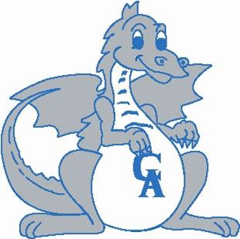**Family Fun** **and Learning** opportunities take place throughout the school year. Dillon Elementary hosts several family nights where our families are able to join us for activities designed to heighten the sense of community that works together “for our kids”. Some of our events include:

October- **Dillon R.O.C.K.S. Family Fun**

November- **Family Math Night (Title 1)**

December/January- **Cookies and Cocoa Night**

March**- Language Arts Fair**

**Title I**

**Academic Interventions** are small group or one-on-one lessons for students who need additional support. Our intervention capability is so great that 40% of our student population is able to receive an intervention from highly qualified, trained tutors and interventionists, in the areas of math or reading. We use the RtI (Response to Intervention) tiered process to select students who demonstrate the greatest need for extra support in addition to classroom instruction.

* Road to the Code is a program for kindergarteners who need additional support learning letters and sounds
* KELI (Kindergarten Early Literacy Intervention) is a small group intervention to support early literacy skills.
* ELI (Early Literacy Intervention) is a one on one reading program for first and second grade students who need additional support.
* LLI (Leveled Literacy Intervention) is a small group reading intervention
* One on One is an intensive literacy intervention with a reading specialist.
* Comprehension Groups are offered to 3rd grade students
* TOMMI (Title One Montessori Math Intervention) is a hands-on program to support the development of number sense.

**Extended Learning Time**



**“Ketchup” Room** is a program run by our highly qualified and trained tutors that is used to help students’ complete homework during lunch recess. If students have been absent or are behind on their work, they can go to the ketchup room to complete their homework.

**Math Mania** is a lunchtime opportunity for students to play math games with a highly qualified and trained tutor. Teachers can choose two students daily to attend this lunchtime event and students are rotated throughout the school year so everybody has the chance to play.

**Our D.R.E.A.M** after school program has been very successful. The program offers a wide variety of enrichment classes in a safe and friendly environment. Students choose classes according to their interests and classes are $3 per class, per week. We have offered classes in computers, soccer, arts and crafts, cooking, singing, and dance. We have had 110 different students participate in the D.R.E.A.M. program and we always have students on a waiting list.

**Student Opportunities**

**Computer Lab –** 1st - 3rd grade students receive additional math and reading practice for 30 minutes daily using an instructional, interactive program called Success Maker. During this time there is a highly qualified and trained tutor that monitors the computer lab so teachers have the opportunity to work with students either individually or in a small group based on need.

**C:\Documents and Settings\lcharmol\Local Settings\Temporary Internet Files\Content.IE5\OJ3Q9QS8\MC900232892[1].wmf**

**TEAM GREEN** - Following the motto “Reduce, Reuse, Recycle”, students are in charge of collecting paper from every classroom and office area that houses a recycling bin. They also collect plastic milk containers from the cafeteria and ink cartridges for recycling as well as gently used clothing to be given away in the spring to families in need.

**Me to We-** follows the motto “Service from Me to help We” students help distribute food from the food bank on weekly basis and have participated in the Global Youth Service Program where they pledge to volunteer in our community.

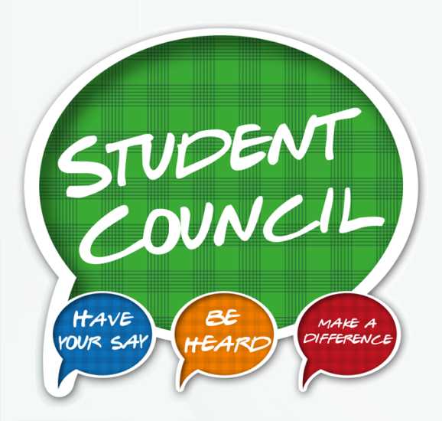**Student Council** - An election is held each year within the 3rd grade to elect Dillon’s newest student council members. Once voted in, students are responsible for raising money to donate to activities to improve the school.  The council had enough sales to purchase an iPad for our school and prizes for our Bucket Filler Wagon (which student council runs on Fridays and the Parent Club provides the prizes on the wagon). We also have a Leukemia & Lymphoma fundraiser every year and collect food for the Food Bank to show students the importance of giving back to those in need.  In the past, the council did a book drive to donate to local shelters.  Members are put in leadership positions to present their messages and act as role models to the younger students.

C:\Users\cdillard\AppData\Local\Microsoft\Windows\Temporary Internet Files\Content.IE5\GK3CQT75\MC900389482[1].wmf**Student Newspaper**- New to our school this year! Our music teacher Mrs. Hall has taken on the responsibility to head a student lead newspaper club. Students decided which department they would like to “work” in and they will incorporate the new and exciting words that they are learning into their news articles. The students will publish a monthly newspaper for students and staff to read. Some article topics they are working on are sports, fashion, crossword puzzles, interviewing adults in the building and several other areas!

**Highly Abled Learners (HAL)** – is a curriculum for our 2nd and 3rd grade students who are performing above grade level and need an extra challenge. These lessons take place once a week for one hour.

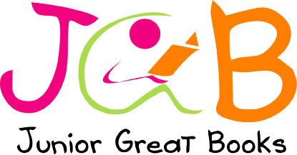**Junior Great Books Club-** Ms. Anderson, our Media Specialist, hosts a book club that meets once a week. Students read out of a book series called Junior Great books. The group has discussions about the stories they read. By doing so, students are helping each other become higher level readers and thinkers.Students also perform a play towards the end of the school year for their classmates.

**Positive Behavior Support**

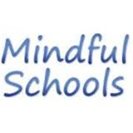

**Mindful Schools -** Our building counselor Ms. Linn, leads lessons, 2 times a week for 8 weeks in every classroom throughout the school year. These lessons teach our students how to use more emotional regulation and how to stay on task with attention and focus. Alongside of teaching these lessons, Ms. Linn also holds regular counseling sessions that address, Grief and Loss, Friendship Groups, Managing Emotions, and individualized sessions to meet student needs.

We also work with individual students to best meet their academic and behavioral/emotional needs. As a team we are able to individualize specific daily routines and schedules to support our students with their specific needs. We have had great success. This is a tremendous amount of work on everyone’s part, but it is worth every second and we wouldn’t have it any other way!



**Teachers as Mentors -** Every teacher along with support staff has 1-2 students they mentor throughout the year. As mentors, our staff meets with these students at least once a week to find out how things are going for the students, to help the students with work, or to simply enjoy each other’s company for a small chat, snack or lunch!

**We are Bucket Fillers!** – What is a Bucket Filler? A Bucket Filler is a person who adds to another person’s well being through positive words and actions. All Dillon staff and students are committed to being Bucket Fillers. Students and staff are recognized as Bucket Fillers in Friday morning announcements and biweekly newsletters. All students who have displayed Bucket Filler behavior get an opportunity to choose a small prize from the Bucket Filler wagon on Fridays.



**Calling All STARS -** Teachers and support staff make ‘good news’ phone calls home each month to recognize the good efforts of our students. Once a phone call has been made, the students name is placed on the bulletin board in our front office.

**Positive Peers** – These students are here to help solve problems! Positive Peers help alongside our recess monitors to be extra eyes and ears as well as role models to their peers. They wear brightly colored vests during indoor and outdoor recess so they are easily visible for students to locate when a problem needs to be solved. When a new student enters Dillon, a Positive Peer member can be assigned as their “Friendship Guide” until they feel comfortable. They can also be used for the “Bucket Filler” wagon, and also help younger students get to their bus.

**MC900438227[1]Positive Peers will:**

* Listen to all sides of a story without interrupting
* Be truthful
* Identify the issue to be solved
* Keep the situation private
* Discuss solutions
* Not take sides-be a friend to all people involved.

**Dillon is continually improving**!

* Our teaching staff participates weekly in *Professional Learning Communities* with a focus on student learning, instruction, and school improvement.
* In 2011 Dillon Elementary was recognized for "Beating the Odds" by the Michigan Department of Education as one of the top 20 schools in Michigan out of 3,011 schools.
* Dillon Elementary uses various achievement data sources which include, MEAP, STAR, AYP targets and DRAs to identify and measure our buildings areas of improvement and needs. Our STAR scores, particularly in math are improving each year.
* Ongoing improvements and upgrades in technology have led to all classrooms being equipped with interactive whiteboards and wi-fi.
* We are committed to increasing our student’s vocabulary knowledge, integrating reading and writing into all content areas, and increasing our focus on informational writing so our students will be college and career ready.
* In mathematics, we have identified fluency (quick recall of addition and subtraction facts), multistep problem solving, and computation as areas students need more practice with.

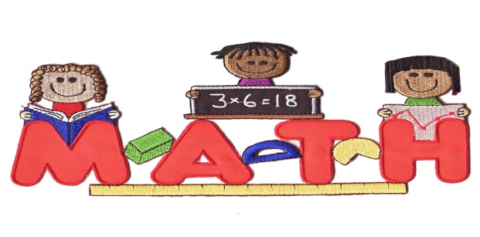We are addressing our Math and ELA needs at every grade level with daily practice and instruction.